**Vision: Improve flexibility of batch transferring and Partwash in system**

**Current Transfer process (refer to the print screens below)**

**OMEGA HUB > Omega > Partwash Omega**

1) Select the process type, upload the file and click process. Printscreen1

2) System will auto process and print out the picklist after transfer done. Printscreen2

3) Have to confirm the transfer done in system.

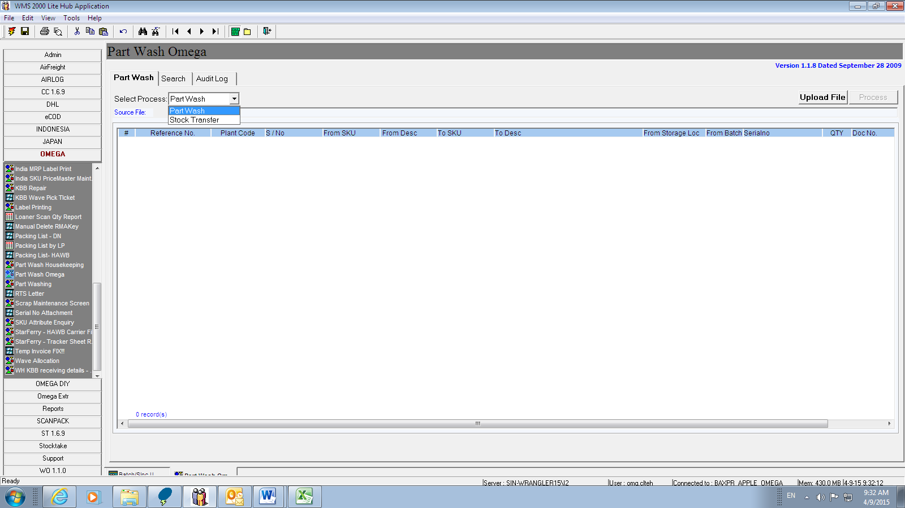

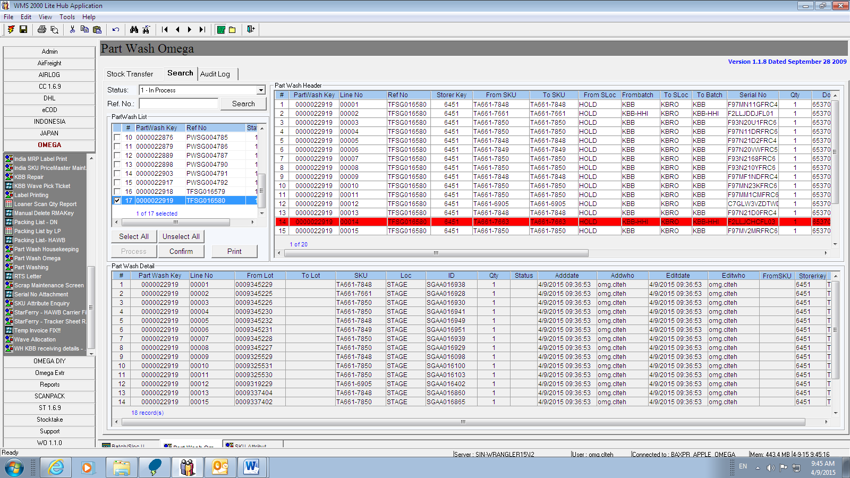

**Problems**

* Auto printing will cause a lot of wastage of papers
* Unable to check which stocks have been transferred and Partwash directly in case there is any issue occurs in system transfer.

**Possible Solution**

* Make the printing part to be optional. Go green.
* Prompt out the issue type if transfer failed in system. For example, not enough quantity in system.
* Create Export function that convert the part wash details into Excel format, can ease operation in system location move and checking.

Feasibility is high.